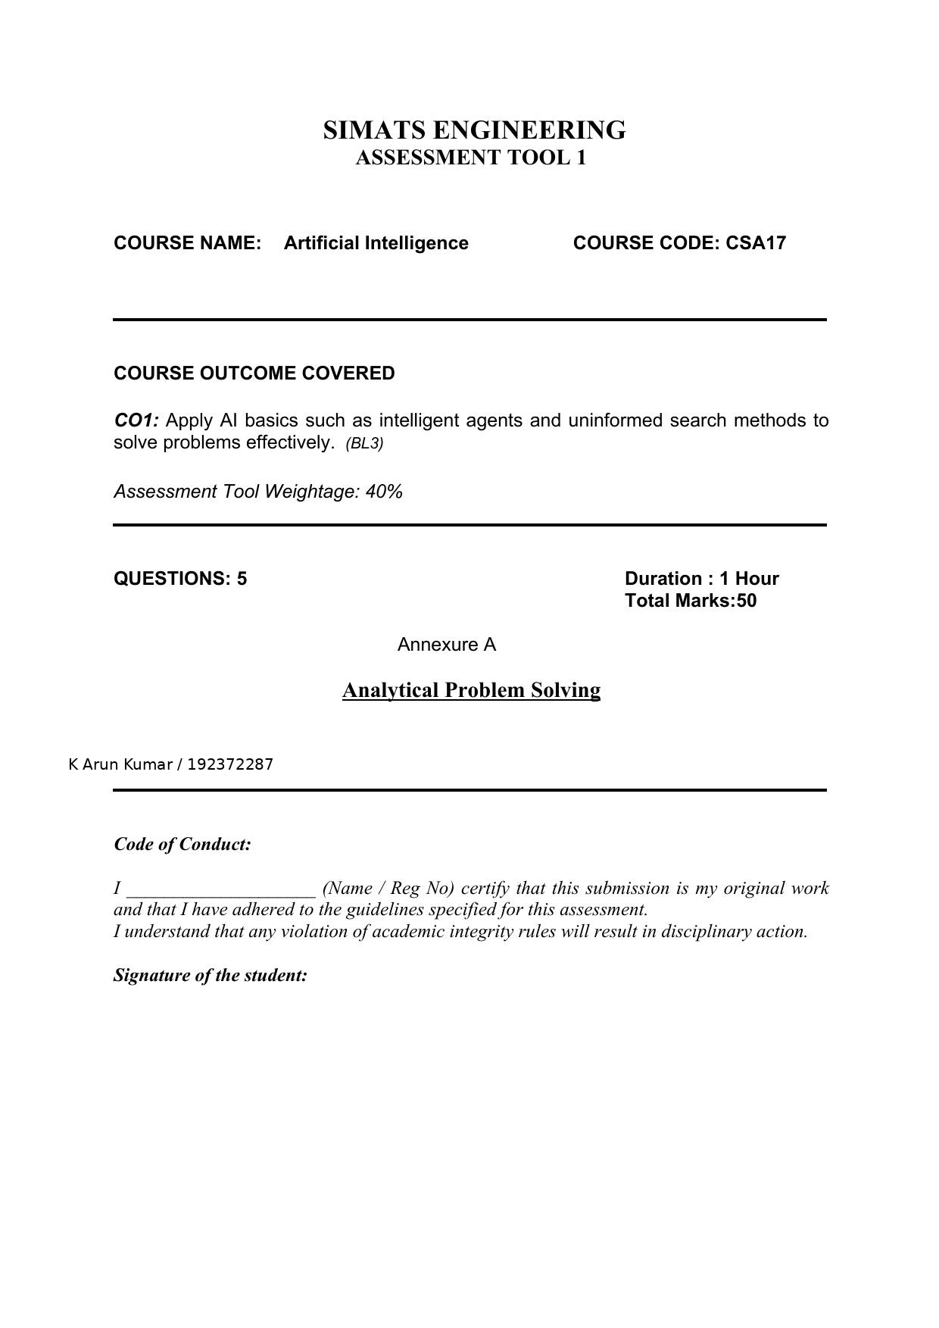

Annexure A
Analytical Problem Solving

Q1. Water Jug Problem
Question: Solve the Water Jug problem: you are given 2 jugs, a 4-gallon one and 3-gallon one. Neither has any measuring maker on it. There is a pump that can be used to fill the jugs with water. How can you get exactly 2 gallons of water into 4-gallon jug? Explicit assumptions: A jug can be filled from the pump, water can be poured out of a jug onto the ground, water can be poured from one jug to another and that there are no other measuring devices available.
Problem formulation:
State = (x, y), where x = amount of water in the 4-gallon jug (0-4) and y = amount in the 3-gallon jug (0-3).
Initial state: (0, 0). Goal state: (2, y) for any y.
Operators: Fill 4-gallon jug; Fill 3-gallon jug; Empty 4-gallon jug; Empty 3-gallon jug; Pour 3-gallon into 4-gallon (until 4-gallon full or 3-gallon empty); Pour 4-gallon into 3-gallon (until 3-gallon full or 4-gallon empty).
Solution path (state-space search):
(0,0) → Fill 3-gallon → (0,3)
(0,3) → Pour 3-gallon into 4-gallon → (3,0)
(3,0) → Fill 3-gallon → (3,3)
(3,3) → Pour 3-gallon into 4-gallon (4-gallon can take only 1 more) → (4,2)
(4,2) → Empty 4-gallon → (0,2)
(0,2) → Pour 3-gallon into 4-gallon → (2,0)
(2,0) → Fill 3-gallon → (2,3) [4-gallon jug now has exactly 2 gallons — GOAL REACHED at the (2,0)/(2,3) state]
Goal achieved: 4-gallon jug contains exactly 2 gallons of water.

Q2. Mars Rover Agent
Question: Find out how Mars Rover, analyse and explore the samples on Mars by answering the following questions: i. What are the percepts for this agent? ii. Characterize the operating environment. iii. What are the actions the agent can take? iv. How can one evaluate the performance of the agent? v. What sort of agent architecture do you think is most suitable for this agent? Why?
i. Percepts:
Camera/images of terrain and rock samples, spectrometer readings (chemical composition), GPS/positional coordinates, obstacle/proximity sensor data, temperature and radiation sensor data, battery/power level, communication signals from the ground control station.
ii. Environment characterization:
Partially observable (rover cannot see the entire Martian surface at once), stochastic (dust storms, terrain slippage are unpredictable), sequential (current actions affect future states, e.g., path taken), dynamic (weather and terrain conditions change over time), continuous (movement, sensor values), and single-agent (from the rover's own perspective, though it may coordinate with a lander/other rovers).
iii. Actions:
Move forward/backward/turn (navigate terrain), extract/collect a soil or rock sample, operate onboard instruments (drill, spectrometer, camera), transmit collected data to Earth/orbiter, avoid obstacles, recharge via solar panels, park/park-hold in place.
iv. Performance measure:
Number and quality of valid samples collected/analysed, accuracy of scientific data reported, distance traveled safely without damage, efficient power/battery usage, time taken to complete assigned tasks, and mission longevity (rover survival time).
v. Suitable agent architecture:
A Learning, Goal-based (or Utility-based) agent architecture built on top of a Model-based agent is most suitable. Reasoning: the environment is partially observable and dynamic, so the rover needs an internal model of the world (model-based) to track state; it must plan sequences of actions to reach science goals like reaching a target rock (goal-based); it should weigh trade-offs like sample quality vs. power/time cost (utility-based); and because Mars conditions are unpredictable and communication delay with Earth is high, the rover must adapt and improve its navigation/decision policy on its own (learning agent).

Q3. 8-Queens Problem — Search Space and Problem Formulation
Question: Explore the search space using search strategies and formulate the problem components for the 8-Queens problem: Place 8 queens on a chessboard such that none of the queens attack any of the others. A given configuration does not represent a solution as the queen in the first column is on the same diagonal as the queen in the last column.
The 8-Queens problem asks that 8 queens be placed on an 8×8 chessboard so that no two queens attack each other (no two share the same row, column, or diagonal).
Problem formulation (as a search problem):
State: Any arrangement of 0 to 8 queens on the board (a partial or complete configuration).
Initial state: An empty board (no queens placed), or in the incremental formulation, 0 queens placed.
Actions/Successor function: Add one queen to any empty square in the leftmost empty column (incremental formulation), producing a new state with one more queen.
Goal test: All 8 queens are placed on the board and no two queens attack each other (no shared row, column, or diagonal).
Path cost: Each step/move costs 1 (constant), since we only care about reaching a valid final configuration, not the cheapest path.
Search space size:
Using the incremental formulation (one queen per column), there are 8 choices per column across 8 columns, giving 8^8 = 16,777,216 possible states before pruning, which is reduced drastically once row/diagonal-conflict constraints are checked at each step (backtracking search).
Why the shown configuration is not a solution:
As noted in the problem, the queen in the first column and the queen in the last column lie on the same diagonal, so they attack each other — violating the diagonal-attack constraint of the goal test.
Suitable strategy:
Backtracking search (depth-first search with constraint checking at each step) is typically used, since it can prune a branch as soon as a partial placement violates a constraint, avoiding full exploration of the 8^8 space.

Q4. OLA Cab Booking — Problem-Solving Agent
Question: A customer wants to travel from one location to another location using OLA Cab booking mobile application. The customer can select any of the cab type as mini, micro, sedan, shared, prime and so on based on his comfort to reach the destination. Identify what type of problem-solving agent can be used and write the pseudocode for the above problem.
Type of problem-solving agent:
A Goal-based agent using search-based problem solving (specifically a simple problem-solving agent that formulates the trip request as a search problem and finds a plan/route+ride option to reach the goal). Since the agent must choose among defined cab options (mini, micro, sedan, shared, prime) and a fixed route to a known destination, this is a well-defined, formulated search problem suited to a goal-based / simple problem-solving agent.
Problem formulation:
States: {pickup location, destination, cab type selected, booking status}.
Initial state: Customer has entered pickup and destination but has not selected a cab type or confirmed booking.
Actions: SelectCabType(type), ConfirmBooking(), CancelBooking(), TrackRide().
Goal test: A cab of the chosen type is booked and assigned to the customer for the requested route.
Path cost: Fare, waiting time, and estimated trip duration for the selected cab type.
Pseudocode:
FUNCTION OLA_Cab_Agent(pickup, destination):
percept ← GetCustomerInput(pickup, destination)
availableCabs ← SearchAvailableCabs(pickup, [mini, micro, sedan, shared, prime])
FOR each cab IN availableCabs:
cab.fare ← EstimateFare(pickup, destination, cab.type)
cab.eta ← EstimateArrivalTime(pickup, cab.location)
DisplayOptions(availableCabs) // goal: help customer choose
chosenCab ← WaitForCustomerSelection(availableCabs)
IF chosenCab ≠ NULL THEN
booking ← ConfirmBooking(chosenCab, pickup, destination)
AssignDriver(booking)
RETURN booking // goal state reached
ELSE
RETURN CancelBooking()
END FUNCTION

Q5. Uniform Cost Search (UCS) — Least-Cost Path from S to G
Question: A logistics company operates a delivery network where packages must be transported between warehouses at minimum cost. Each route between warehouses has an associated travel cost (fuel + time). Determine the least-cost path from the starting warehouse S to the destination warehouse G using the Uniform Cost Search (UCS) algorithm, given the weighted graph (S,A,B,C,D,G with edges S-A=1, A-B=3, B-D=3, A-C=1, C-D=1, C-G=2, D-G=3, S-G=12).
Graph edges (from the figure):
S–A = 1, A–B = 3, B–D = 3, A–C = 1, C–D = 1, C–G = 2, D–G = 3, S–G = 12 (direct).
UCS Execution (expanding node with lowest cumulative path cost g(n) from the frontier, a priority queue):
Frontier: {S:0}
Expand S (cost 0) → generate A (cost 0+1=1), G (cost 0+12=12). Frontier: {A:1, G:12}
Expand A (cost 1, lowest) → generate B (1+3=4), C (1+1=2). Frontier: {C:2, B:4, G:12}
Expand C (cost 2, lowest) → generate D (2+1=3), G (2+2=4, better than 12, update G). Frontier: {D:3, G:4, B:4}
Expand D (cost 3, lowest) → generate G (3+3=6, worse than current 4, discard). Frontier: {G:4, B:4}
Expand G (cost 4) → G is the goal node; since G is now the lowest-cost node in the frontier and it is the goal, UCS terminates here.
Least-cost path: S → A → C → G
Total cost = 1 (S–A) + 1 (A–C) + 2 (C–G) = 4
Interpretation:
The logistics company should route the delivery via warehouse A then C to reach the destination G, at a minimum total travel cost of 4 units (fuel + time), rather than the direct S–G route which costs 12 units — a saving of 8 cost units.



